AMENDED
HOUSING ELEMENT AND
FAIR SHARE PLAN

Town of Harrison
Hudson County, New Jersey

July 2017
Adopted December 14, 2017
Amended December 2019 and Adopted December 17, 2019
Amended April 2020 and Adopted May 11, 2020
Amended May 10, 2021 and Adopted ____, 2021

Prepared by:



Heyer, Gruel & Associates
Community Planning Consultants
236 Broad Street, Red Bank, NJ 07701
(732) 741-2900

AMENDED
HOUSING ELEMENT AND
FAIR SHARE PLAN

Town of Harrison
Hudson County, New Jersey

July 2017
Adopted December 14, 2017
Amended December 2019 and Adopted December 17, 2019
Amended April 2020 and Adopted May 11, 2020
Amended May 10, 2021 and adopted ___, 2021

Prepared by:

Heyer, Gruel & Associates
Community Planning Consultants
236 Broad Street
Red Bank, NJ 07701
(732) 741-2900

The original of this report was signed and
Sealed in accordance with N.J.S.A. 45:14A-12.

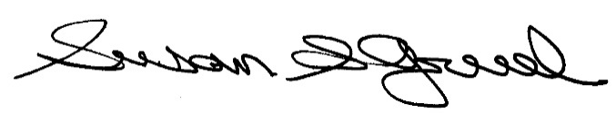

____________________________________
Susan S. Gruel, P.P. #1955

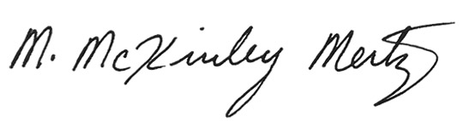

____________________________________
M. McKinley Mertz A.I.C.P., P.P. #6368

TABLE OF CONTENTS
PART 1: HOUSING ELEMENT 5
INTRODUCTION 5
Harrison’s History of Affordable Housing 6
Planning for Affordable Housing 8
Municipal Summary 9
DEMOGRAPHIC CHARACTERISTICS 10
Population 10
Population Composition by Age 11
Households 12
Income 13
Poverty Status 14
Household Costs 15
EXISTING HOUSING CONDITIONS 16
Housing Unit Data 16
Housing Type and Size 17
Housing Growth and Projections 18
Occupancy 19
Housing Values and Contract Rents 20
Housing Conditions 22
EMPLOYMENT DATA 23
Employment Status 25
Class of Worker and Occupation 25
Commuting to Work 27
Covered Employment 28
In-Town Establishments and Employees by Industry: 2017 29
Probable Future Employment Opportunities 30
PART 2: FAIR SHARE PLAN 31
INTRODUCTION 31
SUITABILITY ANALYSIS 32
PRESENT NEED 32
PRIOR ROUND OBLIGATION (1987-1999) 35
ROUND 3 NEED 37
ADDITIONAL AFFIRMATIVE MEASURES 40
USE OF SURPLUS UNITS 42
ADDITIONAL REQUIREMENTS 43
SUMMARY OF FAIR SHARE COMPLIANCE 44
AFFORDABLE HOUSING ORDINANCES AND RESOLUTIONS 45

APPENDIX
Appendix A | 2019 Amended Settlement Agreement with Fair Share Housing Center
Appendix B | Court Orders  - 2020 Order of Fairness and Judgment of Compliance and Repose  - 2021 Consent Order Approving Amended Spending Plan and Scheduling an Amended Fairness and Final Compliance Hearing
Appendix C | HOME Funded Projects  - 774 Harrison Avenue  - 224 N. 2nd Street (Block 11 Lot 30) Deed and Regulatory Agreement
Appendix D | Harrison Senior Housing Documentation  - NJ Housing and Mortgage Finance Agency (HMFA) Subsidy Mortgage Loan Commitment  - Fully Executed HMFA Subsidy Mortgage Loan Commitment Form  - Hudson County Register CDBG Loan and Deed Agreements  - Hudson County Register Property Deed  - Final Billing Documentation
Appendix E | ASH Affordable Senior Housing Zone Documentation  - Ordinance #1404 amending Land Development Ordinance to include provisions for the ASH Affordable Senior Housing Zone
Appendix F | Waterfront Redevelopment Area Documentation  - Ordinance #1414 amending Waterfront Redevelopment Plan
Appendix G | 100% Affordable Development Documentation  - Ordinance #1429 providing funding for the purchase of Lots 6 and 10 in Block 196 for the purpose of developing 100% affordable housing (Adopted December 15, 2020)  - Resolution #2021-56 appropriating funds in the event of a shortfall in funding for the Town’s affordable housing programs (Adopted March 16, 2021)
Appendix H | 2021 Adopted and Court-Approved Spending Plan

PART 1: HOUSING ELEMENT

INTRODUCTION
The need to provide a realistic opportunity for the construction of affordable housing in New Jersey, the country’s densest state, has been recognized for decades. In the case of Southern Burlington County NAACP v. the Township of Mount Laurel, (commonly known as Mount Laurel I), the New Jersey Supreme Court established the doctrine that municipalities in New Jersey have a constitutional obligation to zone for a variety and choice of housing types that would be affordable to low- and moderate-income households. In its Mount Laurel II decision, decided on January 20, 1983 (Mount Laurel II), the Supreme Court expanded the Mount Laurel doctrine by determining that each New Jersey municipality was required to create a realistic opportunity for the construction of housing affordable to low- and moderate-income households sufficient to meet its “fair share” of the need for housing. Developing municipalities were required to address a fair share of the regional need for affordable housing.
In response to the threat of “builder’s remedy” lawsuits endorsed by the Mount Laurel II decision, the New Jersey Legislature adopted the Fair Housing Act in 1985 (Chapter 222, Laws Of New Jersey, 1985). The New Jersey Fair Housing Act (FHA) established the Council on Affordable Housing (COAH) as an administrative alternative to builder’s remedy lawsuits and the concomitant jurisdiction of the courts. COAH was given the responsibility of dividing the state into housing regions, determining regional and municipal fair share affordable housing obligations, and adopting regulations that would establish the guidelines and approaches that municipalities may use in addressing their affordable housing need.
In 2008, the Legislature amended the Fair Housing Act to add requirements for very-low-income housing. Very-low-income households are those in which the gross household income is 30% or less than the region’s median household income. Low-income households are those with incomes no greater than 50 percent of the region’s median household income. Moderate-income households are those with incomes no greater than 80 percent and no less than 50 percent of the region’s median household income. Each is adjusted for household size and is in relation to the median gross income of the housing region in which the municipality is located.
This Housing Element and Fair Share Plan for the Town of Harrison has been prepared in accordance with applicable law. Moreover, the Borough filed a declaratory judgment action pursuant to In re Adoption of N.J.A.C. 5:96 & 5:97 by the N.J. Council on Affordable Housing, 221 N.J. 1 (2015) (“Mount Laurel IV”). In this decision (decided March 10, 2015), the Supreme Court held that since COAH was moribund, trial courts were to resume their role as the forum of first instance for evaluating municipal compliance with Mount Laurel obligations, and also established a transitional process for municipalities to seek temporary immunity and ultimately a Judgment of Compliance and Repose (“JOR”) or the “judicial equivalent” of Substantive Certification from COAH.

Harrison’s History of Affordable Housing
The Harrison Planning Board adopted a Round 3 Housing Element and Fair Share Plan on December 11, 2008 (“2008 Plan”), and on December 30, 2008 petitioned COAH for substantive certification. The Town was deemed complete on February 19, 2009. Harrison then adopted an amended Round 3 Housing Element and Fair Share Plan on October 21, 2009 (“2009 Plan”) under the revised COAH Third Round methodology. Harrison, however, did not receive Third Round substantive certification as a large majority of COAH’s Third Round regulations were invalidated by the Appellate Division on October 10, 2010.
In response to Mount Laurel IV, Harrison filed a Declaratory Judgment action, along with a motion for temporary immunity, on July 8, 2015. The Court appointed Christine A. Nazzaro-Coffone, A.I.C.P., P.P., to serve as the Court’s Special Master.
Due to the current uncertainty in the appropriate manner by which to calculate municipal obligations throughout New Jersey, the Town determined that a settlement with Fair Share Housing Center (“FSHC”) was in the best interest of the Town and its residents. Under the supervision of the Special Master, the Town and its professionals entered into negotiations with representatives of FSHC to settle the Town’s Declaratory Judgment action and seek Court approval for an accepted fair share obligation for the Town. A Fairness Hearing was held on August 23, 2017, at which time the Court approved a draft settlement agreement between the Town and FSHC. The Harrison Planning Board adopted a Housing Element and Fair Share Plan on December 14, 2017 (“2017 Plan”). The Town and FSHC executed a settlement agreement dated November 2, 2018 on November 26, 2018.
Subsequent to the Fairness Hearing and prior to a Compliance Hearing, the Town determined that it would like to amend its Housing Element and Fair Share Plan to include additional provisions for age-restricted affordable housing opportunities. The Town did not “max-out” its age-restricted units in the 2017 Plan and now wished to do so. The Town and FSHC amended the settlement agreement to represent these changes. The amended settlement agreement, dated November 12, 2019, was approved by the Town Council and signed by the Mayor on November 12, 2019 and was signed by Adam Gordon of Fair Share Housing Center at a later date (undated). The amended 2019 settlement agreement can be found in Appendix A. As a result of the amended settlement agreement, the Town adopted an Amended Housing Element and Fair Share Plan on December 17, 2019 and again on May 11, 2020.
A combined Fairness and Compliance hearing was held on May 29, 2020 and the Town received a JOR via court order that was issued on June 4, 2020 (see Appendix B).
In the previous Housing Element and Fair Share Plan, a property owned by the Catholic Church known as the “Holy Cross site” was included as an additional affirmative measure to meet the Town’s obligation. However, the Holy Cross project has stalled, and the Town ultimately determined that it would like to instead pursue an opportunity to develop a 100% affordable development. The Town proposes to acquire five properties along Harrison Avenue to create a 100% affordable development with 25 to 40 family rental units. The Town recently closed on two of the properties (Block 196 Lots 6 and 10). This Amended Housing Element and Fair Share Plan has been prepared to account for that proposed development as an additional affirmative measure. The Town is in the process of amending its settlement agreement with FSHC and will seek an amended JOR from the Court. The Town recently received approval from the Court via consent order dated April 15, 2021 (see Appendix B) for its amended Spending Plan to spend trust fund monies on the acquisition of the properties.
This Amended Housing Element and Fair Share Plan is being prepared to implement the provisions of the Court-approved 2021 Spending Plan and provide for the development of the proposed 100% affordable development.

Planning for Affordable Housing
Pursuant to both the Fair Housing Act and the Municipal Land Use Law (MLUL), municipalities in New Jersey are required to include a housing element in their master plans. The principal purpose of the housing element is to describe the specific, intended methods that a municipality plans to use in order to meet its low and moderate income housing needs. Further, the housing element is meant to demonstrate the existing zoning or planned zoning changes that will allow for the provision of adequate capacity to accommodate household and employment growth projections, to achieve the goal of access to affordable housing for present and future populations. The statutorily required contents of the housing element are:
- An inventory of the municipality’s housing stock by age, condition, purchase or rental value, occupancy characteristics, and type, including the number of units affordable to low and moderate income households and substandard housing capable of being rehabilitated;
- A projection of the municipality’s housing stock, including the probable future construction of low and moderate income housing, for ten years, taking into account, but not necessarily limited to, construction permits issued, approvals of applications for development and probable residential development of lands;
- An analysis of the municipality’s demographic characteristics, including but not necessarily limited to, household size, income level and age;
- An analysis of the existing and probable future employment characteristics of the municipality;
- A determination of the municipality’s present and prospective fair share for low and moderate income housing and its capacity to accommodate its present and prospective housing needs, including its fair share for low and moderate income housing; and
- A consideration of the lands that are most appropriate for construction of low and moderate income housing and of the existing structures most appropriate for conversion to, or rehabilitation for low and moderate income housing, including a consideration of lands of developers who have expressed a commitment to provide low and moderate income housing.

Municipal Summary
The Town of Harrison is 1.22 square miles in size and is located in the northeastern part of New Jersey in Hudson County. The Town had a population of 13,620 in 2010 and is bounded by the Borough of East Newark in the north along the Passaic River, Town of Kearny also to the north, and the City of Newark to the south as well as the east and across the Passaic River.
According to the 2010 Census, the population of Harrison was 13,620, which represents a 5.6 percent decrease from 2000. The US Census Bureau 2013-2017 American Community Survey estimates a total population of 14,025. The 2010 median age in Harrison was 34 years, which was similar to that of Hudson County’s median age of 34.2 years. The median household size in 2010 was 2.8 persons, almost exactly the same as the 2.81 persons in 2000.
The housing stock of the Town is predominantly two-family dwelling units, and a majority of the housing stock (52.4%) was built before 1960. According to the guidelines established by COAH, the Town of Harrison is located in Housing Region 1, a region that consists of Sussex, Bergen, Hudson, and Passaic counties. Income limits are based on median income within each COAH region. Based on the 2021 Regional Income Limits, the median income in Region 1 for a four-person household is $104,066, the moderate-income limit for a four-person household is $83,253, the low-income limit for a four-person household is $52,033, and the very-low-income limit for a four-person household is $31,220.
The Court-approved amended settlement agreement between the Town of Harrison and the FSHC, dated November 12, 2019, assigns a Present Need obligation of 155 units, a Prior Round obligation of 30 units, and a Prospective Need obligation of 429 units.
The Town proposes to address its obligation through the following:
- A Rehabilitation Program
- Inclusionary Zoning
- Developer Fee Ordinance
- Additional affirmative measures, including a 100% affordable development

DEMOGRAPHIC CHARACTERISTICS

Population
The population trends experienced in Harrison, Hudson County, and the State of New Jersey from 1930 through 2017 are shown below. There were 13,620 residents in Harrison in 2010, which was a decrease of 804 people, or 5.6 percent, from the 2000 population but an increase in population has been seen since 2010. From 1930 to 1960 Harrison experienced a decline in population. This trend reversed, however, in the 1960s and from then until 2000, the population saw a steady increase. Between 2000 and 2010, the Town experienced its first decline in population in 50 years. The population regained approximately half of the population that was lost between 2000 and 2010, rising by 3% in 2013. The population rose again in 2015 by 4.3%. According to the 2013-2017 American Community Survey 5-Year Estimates, the Town experienced an 8.7% percent increase in population between 2015 and 2017. The County experienced a continued decline until the 1990s where from 1990 to 2000 the County experienced its largest growth (10.1%) in 60 years. The State, on the other hand, has continued to grow over the last 80 years.
Population Trends
Year | Harrison Town |  |  | Hudson County |  |  | New Jersey
Year | Population | Change |  | Population | Change |  | Population | Change
Year | Population | Number | Percent | Population | Number | Percent | Population | Number | Percent
1930 | 15,601 | - | - | 690,730 | - | - | 4,041,334 | - | -
1940 | 14,171 | -1,430 | -9.2% | 652,040 | -38,690 | -5.6% | 4,160,165 | 118,831 | 2.9%
1950 | 13,490 | -681 | -4.8% | 647,437 | -4,603 | -0.7% | 4,835,329 | 675,164 | 16.2%
1960 | 11,743 | -1,747 | -13.0% | 610,734 | -36,703 | -5.7% | 6,066,782 | 1,231,453 | 25.5%
1970 | 11,811 | 68 | 0.6% | 607,839 | -2,895 | -0.5% | 7,171,112 | 1,104,330 | 18.2%
1980 | 12,242 | 431 | 3.6% | 556,972 | -50,867 | -8.4% | 7,365,011 | 193,899 | 2.7%
1990 | 13,425 | 1,183 | 9.7% | 553,099 | -3,873 | -0.7% | 7,730,188 | 365,177 | 5.0%
2000 | 14,424 | 999 | 7.4% | 608,975 | 55,876 | 10.1% | 8,414,350 | 684,162 | 8.9%
2010 | 13,620 | -804 | -5.6% | 634,277 | 25,302 | 4.2% | 8,791,894 | 377,544 | 4.5%
2013  Estimates | 14,025 | 405 | 3.0% | 644,605 | 10,328 | 1.6% | 8,832,406 | 40,512 | 0.5%
2015  Estimates | 14,629 | 604 | 4.3% | 662,619 | 28,342 | 4.4% | 8,904,413 | 112,519 | 1.3%
2017  Estimates | 15,898 | 1,269 | 8.7% | 679,756 | 35,151 | 5.3% | 8,960,161 | 127,755 | 1.4%
Source: U.S. Census Bureau, 2013-2017 American Community Survey 5-Year Estimates

Population Composition by Age
The median age of the residents in Harrison in 2010 was 34 years. Analysis of age group characteristics provides insight into the actual changes in population. This comparison is helpful in determining impacts these changes have on housing needs, community facilities and services for the municipality. The composition of Harrison has shifted somewhat since 2000. Every age group saw a decrease except for the 55 to 64 age cohort, which increased by 22.9 percent. The most significant decrease was experienced in the 35 to 44 age cohort, which decreased by 18.1 percent, followed by the 65 and over cohort, which declined by 14.8 percent.
Population by Age 2000 and 2010, Town of Harrison
Population | 2000 |  | 2010 |  | Change, 2000 to 2010
Population | Number | Percent | Number | Percent | Number | Percent
Total population | 14,424 | 100.0% | 13,620 | 100.0% | -804 | -5.6%
Under 5 years | 931 | 6.5% | 858 | 6.3% | -73 | -7.8%
5 to 14 | 1,626 | 11.3% | 1,506 | 11.1% | -120 | -7.4%
15 to 24 | 2,072 | 14.4% | 1,954 | 14.3% | -118 | -5.7%
25 to 34 | 2,810 | 19.5% | 2,729 | 20.0% | -81 | -2.9%
35 to 44 | 2,492 | 17.3% | 2,042 | 15.0% | -450 | -18.1%
45 to 54 | 1,840 | 12.8% | 1,829 | 13.4% | -11 | -0.6%
55 to 64 | 1,172 | 8.1% | 1,440 | 10.6% | 268 | 22.9%
65 and over | 1,481 | 10.3% | 1,262 | 9.3% | -219 | -14.8%
Source: U.S. Census Bureau
Hudson County similarly saw its greatest increase in the 55 to 64 age cohort (25.2%) but also experienced moderate increases in the 45 to 54 cohort (14.7%), the 25 to 34 cohort (10.4%) and in those under 5 years (9.9%). The largest decrease (13.2%) was seen in the 5 to 14 age cohort.
Population by Age 2000 and 2010, Hudson County
Population | 2000 |  | 2010 |  | Change, 2000 to 2010
Population | Number | Percent | Number | Percent | Number | Percent
Total population | 609,975 | 100.0% | 634,277 | 100.0% | 24,302 | 4.0%
Under 5 years | 38,756 | 6.4% | 42,586 | 6.7% | 3,830 | 9.9%
5 to 14 | 76,700 | 12.6% | 66,584 | 10.5% | -10,116 | -13.2%
15 to 24 | 85,412 | 14.0% | 85,641 | 13.5% | 229 | 0.3%
25 to 34 | 119,073 | 19.5% | 131,508 | 20.7% | 12,435 | 10.4%
35 to 44 | 97,727 | 16.0% | 96,716 | 15.2% | -1,011 | -1.0%
45 to 54 | 72,379 | 11.9% | 82,985 | 13.1% | 10,606 | 14.7%
55 to 64 | 49,657 | 8.1% | 62,180 | 9.8% | 12,523 | 25.2%
65 and over | 69,271 | 11.4% | 63,085 | 9.9% | -6,186 | -8.9%
Source: U.S. Census Bureau

Households
A household is defined as one or more persons, either related or not, living together in a housing unit. In 2010 there was a total of 4,869 households in Harrison. A little less than half (48.9%) were occupied by two persons or less. The average household size of the Town in 2010 was 2.8, slightly higher than that of the County’s average of 2.54. While the Town’s largest percentage of households was a two-person household (26.8%), the County’s largest percentage of household size was a one-person household at 29.9 percent.
Household Size: Occupied Housing Units
Town of Harrison and Hudson County, 2010
 | Harrison |  | Hudson County
 | Number | Percent | Number | Percent
Total Households | 4,869 | 100.0% | 246,437 | 100.0%
1-person household | 1,078 | 22.1% | 73,741 | 29.9%
2-person household | 1,304 | 26.8% | 71,762 | 29.1%
3-person household | 1,052 | 21.6% | 42,935 | 17.4%
4-person household | 808 | 16.6% | 31,581 | 12.8%
5-person household | 380 | 7.8% | 15,098 | 6.1%
6-person household | 159 | 3.3% | 6,401 | 2.6%
7-or-more-person household | 88 | 1.8% | 4,919 | 2.0%
Average Household Size | 2.8 |  | 2.54
Source: U.S. Census Bureau
Family households are defined as two or more persons living in the same household, related by blood, marriage or adoption. They do not include same-sex married couples. Most households in the Town in 2010 were family households, comprising 67 percent of all households. The average family size was 3.23. The majority of family households (66%) were married-couple families, of which a little less than half had children under the age of 18. Approximately 22 percent of all households were one-person households, of which 49.9 percent were male householders and 50.1 percent were female householders.
In providing more detail of American households, the 2010 Census included the sub-groups of non-traditional households: Other family and Non-family households. “Other” family households made up 22.8 percent of all households, of which 731, roughly 66 percent, were female householders with no husband present. Non-family households are defined as households that consist of a householder living alone or sharing the home exclusively with people whom he/she is not related. Non-family households comprised approximately 11 percent of all households in the Town.

Household Size and Type, 2010
Town of Harrison
 |  |  |  | Total | Percent
Total Households |  |  |  | 4,869 | 100.0%
1 person household |  |  |  | 1,078 | 22.1%
 | Male householder |  |  | 538 | 49.9%
 | Female householder |  |  | 540 | 50.1%
2 or more person household |  |  |  | 3,791 | 77.9%
 | Family households |  |  | 3,260 | 67.0%
 |  | Married Couple Family |  | 2,151 | 66.0%
 |  |  | With own children under 18 years | 1,030 | 47.9%
 |  |  | No children under 18 years | 1,121 | 52.1%
 | Other Family |  |  | 1,109 | 22.8%
 |  | Male householder, no wife present |  | 378 | 34.1%
 |  |  | With own children under 18 years | 163 | 43.1%
 |  |  | No own children under 18 year | 215 | 56.9%
 |  | Female householder, no husband present |  | 731 | 65.9%
 |  |  | With own children under 18 years | 355 | 48.6%
 |  |  | No own children under 18 year | 376 | 51.4%
Nonfamily Households |  |  |  | 531 | 10.9%
 | Male householder |  |  | 353 | 66.5%
 | Female householder |  |  | 178 | 33.5%
Average Family Size |  |  |  | 3.23
Source: U.S. Census Bureau

Income
As measured in 2017, the Town of Harrison had a median household income was $61,168, $15,307 less than that of the State, and only $1,513 less that of Hudson County. In 2017, the per capita income was $28,892, which is $10,177 less than the State’s and $7,018 less than the County’s.
Per Capita and Household Income
 | 2017 Per Capita Income | 2017 Median Household Income
Harrison | $28,892 | $61,168
Hudson County | $35,910 | $62,681
New Jersey | $39,069 | $76,475
Source: 2013-2017 American Community Survey 5-Year Estimates
In 2017, nearly 60 percent of all households in the Town earned $50,000 or more, with the largest percentage of households in the $50,000 to $74,999 range (22%). This percentage was followed by those households that earned $75,000 to $99,999 (20.2%) and finally by those who earned between $100,000 and $149,999 at 14.6%. About 26 percent of households earned less than $35,000. The income distribution in Hudson County was similar to that of Harrison with the most common income bracket also being the $50,000 to $74,999 range (15.8%).
Household Income
Harrison and Hudson County, 2013-2017 Estimates
 | Harrison |  | Hudson County
 | Number | Percent | Number | Percent
Total Households | 5,622 | 100.0% | 252,352 | 100.0%
Less than $10,000 | 330 | 5.9% | 20,235 | 8.0%
$10,000 to $14,999 | 186 | 3.3% | 11,847 | 4.7%
$15,000 to $24,999 | 434 | 7.7% | 23,857 | 9.5%
$25,000 to $34,999 | 493 | 8.8% | 20,472 | 8.1%
$35,000 to $49,999 | 544 | 9.7% | 19,001 | 7.5%
$50,000 to $74,999 | 1,238 | 22.0% | 39,790 | 15.8%
$75,000 to $99,999 | 1,134 | 20.2% | 27,354 | 10.8%
$100,000 to $149,999 | 822 | 14.6% | 36,680 | 14.5%
$150,000 to $199,999 | 381 | 6.8% | 19,131 | 7.6%
$200,000 or more | 297 | 5.3% | 25,429 | 10.1%
Median Household Income | $61,168 |  | $62,681
Source: 2013-2017 American Community Survey 5-Year Estimates

Poverty Status
In 2017, approximately 16 percent of the Harrison’s residents aged 18 and older were living below the poverty line. Of the 2,567 persons living below the poverty line, the majority (65.5%) fell into the age range of 18 to 64 years old. About 30 percent were under the age of eighteen, and roughly 4 percent were seniors, a marked decrease from 11 percent in 2013. The County saw similar numbers with 17.1 percent of its population below the poverty line.
Poverty Status
Harrison and Hudson County, 2013-2017 Estimates
 |  | Harrison |  | Hudson County
 |  | Number | Percent | Number | Percent
Total persons |  | 15,886 | - | 672,241 | -
Total persons below poverty level |  | 2,567 | 16.2% | 115,254 | 17.1%
 | Under 18 | 780 | 30.4% | 35,405 | 30.7%
 | 18 to 64 | 1,681 | 65.5% | 67,539 | 58.6%
 | 65 and over | 106 | 4.1% | 12,310 | 10.7%
Source: 2013-2017 American Community Survey 5-Year Estimates

Household Costs
The tables below show the expenditures for housing for those who own and rent in Harrison. Most people in the Town lived in homes they rented (71%), of which 40.5 percent spent 30 percent or more of their household income on housing. Owner-occupied households make up 29 percent of the households in Harrison, of which 44.4 percent spent 30 percent or more of their household income on housing. General affordability standards set a limit at 30 percent of gross income to be allocated for owner-occupied housing costs and 28 percent of gross income to be allocated for renter-occupied housing costs.
Selected Monthly Owner Costs as a Percentage of Household Income
2013-2017 Estimates
 | Harrison |  | Hudson County
 | Number | Percent | Number | Percent
Total Owner-Occupied Housing Units | 1,567 | 100.0% | 79,116 | 100.0%
Less than 15% | 395 | 25.2% | 18,241 | 23.1%
15 to 19% | 174 | 11.1% | 10,794 | 13.6%
20 to 24% | 204 | 13.0% | 10,018 | 12.7%
25 to 29% | 135 | 8.6% | 7,438 | 9.4%
30 to 34% | 86 | 5.5% | 5,845 | 7.4%
35% or more | 549 | 35.0% | 26,096 | 33.0%
Not computed | 24 | 1.5% | 684 | 0.9%
Source: 2013-2017 American Community Survey 5-Year Estimates
Gross Rent as a Percentage of Household Income
2013-2017 Estimates
 | Harrison |  | Hudson County
 | Number | Percent | Number | Percent
Total Renter-Occupied Housing Units | 3,846 | 100.0% | 166,193 | 100.0%
Less than 15% | 616 | 16.0% | 24,832 | 14.9%
15 to 19% | 452 | 11.8% | 22,330 | 13.4%
20 to 24% | 620 | 16.1% | 21,336 | 12.8%
25 to 29% | 451 | 11.7% | 18,327 | 11.0%
30 to 34% | 364 | 9.5% | 15,374 | 9.3%
35% or more | 1,343 | 34.9% | 63,994 | 38.5%
Not computed | 209 | 5.4% | 7,043 | 4.2%
Source: 2013-2017 American Community Survey 5-Year Estimates
Similar to Harrison, a large majority (68%) of Hudson County residents rent their home. Roughly 48 percent of all County renter-occupied households and 40.4 percent of all owner-occupied households spent 30 percent or more of their household income on housing.

EXISTING HOUSING CONDITIONS

Housing Unit Data
Approximately 52 percent of Harrison’s housing stock consists of structures older than 50 years with the median year of construction landing in 1967. According to the 2010 Census, Harrison had a total of 5,228 housing units. A majority of the units (3,385 or 69.5%) were renter-occupied while 1,474 units (30.3%) were owner-occupied. Small surges of housing construction were seen in the 1970s and 2000s, but for the most part construction has remained relatively steady. The 2013-2017 American Community Survey 5-Year Estimates indicate that roughly 1,265 new housing units have been built since 2000. A significant amount of construction has also occurred in recent years within the Harrison Waterfront Redevelopment Area. Due to the nature of how recently development has come about along the Waterfront, residential construction projects may not appear in the Census and ACS data shown below.
Housing Data
Harrison, 2010
 |  | Number | Percent
Total Housing Units |  | 5,228 | 100.0%
Occupied Housing Units |  | 4,869 | 93.1%
 | Owner Occupied | 1,474 | 30.3%
 | Renter Occupied | 3,385 | 69.5%
Source: 2010 U.S. Census
Year Structure Built
Harrison
 | Number | Percent
Built 1939 or earlier | 1,515 | 25.6%
Built 1940 to 1949 | 304 | 5.1%
Built 1950 to 1959 | 751 | 12.7%
Built 1960 to 1969 | 527 | 8.9%
Built 1970 to 1979 | 847 | 14.3%
Built 1980 to 1989 | 438 | 7.4%
Built 1990 to 1999 | 263 | 4.5%
Built 2010 to 2013 | 416 | 7.0%
Built 2014 or later | 245 | 4.1%
Total | 5,910 | 100.0%
Median Year Structure Built | 1967
Source: 2013-2017 American Community Survey 5-Year Estimates

Housing Type and Size
The majority of the housing stock in Harrison is two-family dwelling units. In 2017, there were 2,128 two-family housing structures representing 36 percent of the housing stock. Three- to four-family structures were the second most common housing type with 1,304 units or 22 percent of the Town’s housing stock. Approximately 12.5 percent of the housing stock is single-family detached or attached, while 11.5 percent consists of 50 or more units. The median number of rooms within housing structures in the Town was 4.5, with 31.4 percent having 5 rooms.
Housing Type and Size
Harrison, 2017 Estimates
Units in Structure | Total | Percent
Total | 5,910 | 100.0%
1, detached | 551 | 9.3%
1, attached | 188 | 3.2%
2 | 2,128 | 36.0%
3 or 4 | 1,302 | 22.0%
5 to 9 | 467 | 7.9%
10 to 19 | 299 | 5.1%
20 to 49 | 289 | 4.9%
50 or more | 681 | 11.5%
Mobile home | 5 | 0.1%
Boat, RV, van, etc. | 0 | 0.0%
Rooms | Total | Percent
1 room | 324 | 5.5%
2 rooms | 195 | 3.3%
3 rooms | 847 | 14.3%
4 rooms | 1635 | 27.7%
5 rooms | 1858 | 31.4%
6 rooms | 571 | 9.7%
7 rooms | 147 | 2.5%
8 rooms | 119 | 2.0%
9 or more rooms | 214 | 3.6%
Median number of rooms | 4.5
Source: 2013-2017 American Community Survey 5-Year Estimates

Housing Growth and Projections
For the period between January 2000 and December 2019, the Town issued building permits authorizing the development of 4,358 units, which averages to approximately 229 units per year. The observed increase in multi-family development over the 19-year span is focused in the Town’s Waterfront Redevelopment Area.
If the average rate of 229 units per year were to remain relatively constant over the next 10-year period, the Town could expect to see an additional 2,290 residential units authorized by the 2020. External factors such as zoning, redevelopment, environmental constraints, and economic cycles may cause this projection to fluctuate. As detailed in the Fair Share Plan, found in Part 2 of this Housing Element and Fair Share Plan, at the minimum residential development can be expected through the execution of the settlement agreement and the Waterfront Redevelopment Plan.
Housing Units Authorized by Building Permits: 2000-2019*
Harrison
Year | 1 & 2 Family | Multi Family | Mixed-Use | Total
2000-2003 | - | - | - | 62
2004 | 24 | 0 | 0 | 24
2005 | 31 | 0 | 0 | 31
2006 | 81 | 156 | 0 | 237
2007 | 23 | 497 | 0 | 520
2008 | 10 | 0 | 0 | 10
2009 | 14 | 1 | 1 | 16
2010 | 4 | 6 | 0 | 10
2011 | 9 | 0 | 0 | 9
2012 | 18 | 467 | 0 | 485
2013 | 15 | 4 | 0 | 19
2014 | 18 | 448 | 0 | 466
2015 | 24 | 286 | 0 | 310
2016 | 47 | 409 | 0 | 456
2017 | 18 | 1,051 | 0 | 1069
2018 | 45 | 0 | 0 | 45
2019 | 37 | 552 | 0 | 589
Total 2000-2019 | 418 | 3,877 | 1 | 4,358
19-Year Average |  |  |  | 229
10-Year Projection (2020-2030) |  |  |  | 2,290
Source: State of New Jersey Department of Community Affairs Building Permits: Yearly Summary Data
*The DCA Construction Reporter did not begin to report housing permits by type until 2004.

Occupancy
According to the 2010 Census, of the 5,228 units in Harrison, 4,896 (93.1%) were occupied while only 359 (6.9%) were vacant. Of those units that were vacant, about 50 percent were for rent, another 14.2 percent were for sale, and 2.5 percent were for seasonal, recreational or occasional use.
Occupancy Status
Harrison, 2010
 |  | Total | Percent
Total Housing Units |  | 5,228 | 100%
Occupied |  | 4,869 | 93.1%
Vacant Housing Units |  | 359 | 6.9%
 | For Rent/Rented Not Occupied | 178 | 49.6%
 | For Sale Only | 51 | 14.2%
 | For Seasonal, Recreational or Occasional Use | 9 | 2.5%
 | Other Vacant | 105 | 29.2%
Source: 2010 U.S. Census

Housing Values and Contract Rents
In 2017, a majority of the owner-occupied housing units in Harrison (81.7%) were valued at over $200,000. Approximately 18 percent of all occupied units were financed by a mortgage. Housing values for owner-occupied housings units are listed in the table below along with mortgage status data. A total of 29.2 percent of all owner-occupied units had a value within the $200,000 and $299,999 range. The second most common value range was between $300,000 to $399,999 comprising 28.1 percent of all owner-occupied units. The median value of an owner-occupied housing unit in Harrison was $309,000. Though most units were covered by a mortgage (57%), a significant percentage of units (43%) had no mortgage at all. The County’s trends mirror that of the Town with roughly 85 percent of the homes valued at $200,000 and over, and roughly 68 percent of housing units functioning with a mortgage, contract to purchase, or similar debt. Approximately 32 percent of the owner-occupied housing in the County poses no mortgage.
Value for Owner-Occupied Housing Units, 2017 Estimates
 | Harrison |  | Hudson County
 | Number | Percent | Number | Percent
Total | 1,567 | 100.0% | 79,116 | 100.0%
Less than $50,000 | 66 | 4.2% | 2,300 | 2.9%
$50,000 to $99,999 | 29 | 1.9% | 1,226 | 1.5%
$100,000 to $149,999 | 18 | 1.1% | 2,653 | 3.4%
$150,000 to $199,999 | 174 | 11.1% | 5,802 | 7.3%
$200,000 to $299,999 | 457 | 29.2% | 18,054 | 22.8%
$300,000 to $399,999 | 440 | 28.1% | 19,254 | 24.3%
$400,000 to $499,999 | 153 | 9.8% | 10,927 | 13.8%
$500,000 and greater | 230 | 14.7% | 18,900 | 23.9%
Median Value | $309,000 |  | $349,500
Source: 2013-2017 American Community Survey 5-Year Estimates
Mortgage Status, 2017 Estimates
 | Harrison |  | Hudson County
 | Number | Percent | Number | Percent
Housing units with a mortgage, contract to purchase, or similar debt: | 893 | 57.0% | 53,984 | 68.2%
With either a second mortgage or home equity  loan, but not both: | 137 | 8.7% | 6,509 | 8.2%
Second mortgage only | 22 | 1.4% | 1,180 | 1.5%
Home equity loan only | 115 | 7.3% | 5,329 | 6.7%
Both second mortgage and home equity loan | 8 | 0.5% | 416 | 0.5%
No second mortgage and no home equity loan | 748 | 47.7% | 47,059 | 59.5%
Housing units without a mortgage | 674 | 43.0% | 25,132 | 31.8%
Source: 2013-2017 American Community Survey 5-Year Estimates
According to the 2013-2017 American Community Survey 5-year Estimates, the median contract rent in Harrison was $1,170. The highest percentage of renters (45.2%) paid between $1,000 and $1,499 for rent, followed by 15.8 percent who paid between $1,500 and $1,999 for rent. The County’s median contract rent was similar to the Town’s at $1,147.
Contract Rent, 2017 Estimates
 | Harrison |  | Hudson County
 | Number | Percent | Number | Percent
Total Renter Occupied Units | 4,055 | 100.0% | 173,236 | 100.0%
Less than $200 | 15 | 0.4% | 3,898 | 2.3%
$200 to $499 | 84 | 2.1% | 12,769 | 7.4%
$500 to $699 | 184 | 4.5% | 9,863 | 5.7%
$700 to $899 | 512 | 12.6% | 21,740 | 12.5%
$900 to $999 | 335 | 8.3% | 15,225 | 8.8%
$1,000 to $1,499 | 1,833 | 45.2% | 58,156 | 33.6%
$1,500 to $1,999 | 642 | 15.8% | 21,020 | 12.1%
$2,000 or more | 367 | 9.1% | 27,625 | 15.9%
No cash rent | 73 | 1.8% | 2,940 | 1.7%
Median Contract Rent | $1,170 |  | $1,147
Source: 2013-2017 American Community Survey 5-Year Estimates
According to the 2013-2017 American Community Survey 5-Year Estimates, the median contract rent in Harrison was $1,170 per month ($14,040‬ annually). A minimum income of $46,800‬ ($14,040/0.30) would be necessary to afford the Town’s median contract rent. Therefore, an estimated minimum of 26 percent of all households within the Town could not afford to live in a dwelling unit at or above the median contract rent. Similarly, on a Countywide scale, an estimated 30 percent of all households could not afford to live within a residence whose rent is at or above the median contract rent.

Housing Conditions
The following table details the condition of the housing within Harrison. Overcrowding and age, plumbing, and kitchen facilities are used to determine housing deficiency. In 2017, there were 65 owner-occupied units in Harrison that experienced overcrowding (more than one person per room). Renter-occupied dwellings saw a total of 140 overcrowded units. Throughout the Town, 39 units lacked complete plumbing facilities and 91 units lacked complete kitchen facilities.
Housing Conditions
Harrison, 2017 Estimates
 | Number | Percent
House Heating Fuel: Occupied Housing Units
Total | 5,622 | 100.0%
Utility gas | 4,411 | 78.5%
Bottled, tank, or LP gas | 116 | 2.1%
Electricity | 746 | 13.3%
Fuel oil, kerosene, etc. | 284 | 5.1%
Coal or coke | 0 | 0.0%
Wood | 0 | 0.0%
Solar energy | 12 | 0.2%
Other fuel | 8 | 0.1%
No fuel used | 45 | 0.8%
Occupants per Room: Occupied Housing Units
Total | 5,622 | 100.0%
Owner-Occupied (Over 1.0) | 65 | 27.9%
Renter-Occupied (Over 1.0) | 140 | 72.1%
Facilities: Total Units
Total | 5,622 | 100.0%
Lacking complete plumbing facilities | 39 | 0.7%
Lacking complete kitchen facilities | 91 | 1.6%
Telephone Service: Occupied Housing Units
Total | 5,622 | 100.0%
No Service | 200 | 3.6%
Source: 2013-2017 American Community Survey 5-Year Estimates

EMPLOYMENT DATA
The following tables detail changes in employment from 2007 to 2019 in Harrison, Hudson County, and the State of New Jersey. While the unemployment rate of Harrison Town experienced minimal fluctuation during this time, it jumped 4.6 percent in 2009 to reach a high point of 11.1 percent. The Town unemployment rate remained around 9 percent for the following three years before it started declining again in 2013. The unemployment rate of the Town has continued to progress in a similar manner to that of the County, both experiencing parallel increases and declines over the past decade. While the Town had a higher unemployment rate than the State in the years leading up to 2009, since the Recession, the numbers experienced in the Town are similar to that of the State.
Harrison Employment and Residential Labor Force: 2007-2019
Year | Labor Force | Employment | Unemployment | Unemployment Rate
2007 | 7,006 | 6,655 | 351 | 5.0%
2008 | 7,263 | 6,793 | 470 | 6.5%
2009 | 7,469 | 6,641 | 827 | 11.1%
2010 | 7,476 | 6,811 | 666 | 8.9%
2011 | 7,487 | 6,821 | 667 | 8.9%
2012 | 7,546 | 6,849 | 697 | 9.2%
2013 | 8,071 | 7,470 | 601 | 7.4%
2014 | 8,025 | 7,516 | 509 | 6.3%
2015 | 8071 | 7612 | 459 | 5.7%
2016 | 8,404 | 8,010 | 394 | 4.7%
2017 | 8,963 | 8,593 | 370 | 4.1%
2018 | 8,874 | 8,572 | 302 | 3.4%
2019 | 9,298 | 9,011 | 287 | 3.1%
Source: NJ Dept. of Labor & Workforce Development Labor Force Estimates

Hudson County Employment and Residential Labor Force: 2007-2019
Year | Labor Force | Employment | Unemployment | Unemployment Rate
2007 | 290,000 | 275,600 | 14,500 | 5.0%
2008 | 294,000 | 275,800 | 18,300 | 6.2%
2009 | 300,200 | 268,600 | 31,600 | 10.5%
2010 | 352,903 | 319,151 | 33,752 | 9.6%
2011 | 357,354 | 324,656 | 32,698 | 9.2%
2012 | 360,706 | 328,634 | 32,072 | 8.9%
2013 | 359,472 | 331,172 | 28,300 | 7.9%
2014 | 357,191 | 334,435 | 22,756 | 6.4%
2015 | 358,799 | 339,480 | 19,319 | 5.4%
2016 | 359,152 | 342,335 | 16,817 | 4.7%
2017 | 360,296 | 344,612 | 15,684 | 4.4%
2018 | 357,639 | 343,787 | 13,852 | 3.9%
2019 | 361,189 | 349,372 | 11,817 | 3.3%
Source: NJ Dept. of Labor & Workforce Development Labor Force Estimates
New Jersey Employment and Resident Labor Force: 2007-2019
Year | Labor Force | Employment | Unemployment | Unemployment Rate
2007 | 4,441,800 | 4,251,800 | 190,000 | 4.3%
2008 | 4,504,400 | 4,264,000 | 240,500 | 5.3%
2009 | 4,550,600 | 4,138,600 | 412,100 | 9.1%
2010 | 4,555,300 | 4,121,500 | 433,900 | 9.5%
2011 | 4,565,300 | 4,138,500 | 426,800 | 9.3%
2012 | 4,588,000 | 4,160,000 | 428,000 | 9.3%
2013 | 4,548,600 | 4,173,800 | 374,700 | 8.2%
2014 | 4,487,000 | 4,183,500 | 303,500 | 6.6%
2015 | 4,489,000 | 4,229,200 | 259,800 | 5.8%
2016 | 4,474,700 | 4,252,100 | 222,600 | 5.0%
2017 | 4,453,500 | 4,247,500 | 206,000 | 4.6%
2018 | 4,422,900 | 4,239,600 | 183,400 | 4.1%
2019 | 4,493,100 | 4,333,300 | 159,800 | 3.6%
Source: NJ Dept. of Labor & Workforce Development Labor Force Estimates

Employment Status
The 2013-2017 American Community Survey 5-year Estimates reveal that roughly 71 percent of Harrison’s 16 years and over population is in the labor force. The County’s employment status closely reflects the Town’s trends. About one third of both the Town’s and the County’s over 16 population is not in the labor force (29.4% and 31.2% respectively).
Employment
Harrison, 2017 Estimates
 | Harrison |  | Hudson County
 | Number | Percent | Number | Percent
Population 16 years and over | 12,785 | 100.0% | 554,677 | 100.0%
In labor force | 9,030 | 70.6% | 381,440 | 68.8%
Civilian Labor Force | 9,030 | 70.6% | 381,266 | 68.7%
Employed | 8,254 | 64.6% | 354,105 | 63.8%
Unemployed | 776 | 6.1% | 27,161 | 4.9%
Armed Forces | 0 | 0.0% | 174 | 0.0%
Not in labor force | 3,755 | 29.4% | 173,237 | 31.2%
Source: 2013-2017 American Community Survey 5-Year Estimates

Class of Worker and Occupation
The majority of workers (83.2%) living in Harrison in 2017 were a part of the private wage and salary worker group. This group includes people who work for wages, salary, commission, and tips for a private for-profit employer or a private not-for-profit, tax-exempt or charitable organization. The second largest category was government worker, making up 10.3 percent of the workforce. Roughly 6.4 percent of workers were self-employed.
Class of Worker
Harrison, 2017 Estimates
 | Number | Percent
Total | 8,254 | 100.0%
Private Wage and Salary Worker | 6,869 | 83.2%
Government Worker | 851 | 10.3%
Self-Employed Worker | 531 | 6.4%
Unpaid Family Worker | 3 | 0.0%
Source: 2013-2017 American Community Survey 5-Year Estimates
Those who worked within the private wage field were concentrated in management and professional services at roughly 39 percent. The second and third most common were those of service occupations and sales and office occupations at 18.8 percent and 18.1 percent respectively. Production, transportation and material moving occupations shifted from employing 19.4 percent of the workforce to 13.6 percent. The smallest portion of the workforce (10.4%) is the natural resources, construction and maintenance occupations.

Employment by Occupation
Harrison, 2017 Estimates
 | Number | Percent
Employed Civilian population 16 years and over | 8,254 | 100.0%
Management, business, science and arts occupations | 3,224 | 39.1%
Service occupations | 1,555 | 18.8%
Sales and office occupations | 1,493 | 18.1%
Natural resources, construction and maintenance occupations | 857 | 10.4%
Production, Transportation and material moving occupations | 1,125 | 13.6%
Source: 2013-2017 American Community Survey 5-Year Estimates
By industry, employment is dispersed fairly evenly. The most common industry by a small margin is the educational services, health care and assistance sector, employing 18.8 percent of Harrison residents. The second most common industry employing 17.3 percent is professional, scientific and management and administrative and waste management services.
Employment by Industry
Harrison, 2017 Estimates
Industry | Number | Percent
Civilian employed population 16 years and over | 8,254 | 100.0%
Agriculture, forestry, fishing and hunting, mining | 0 | 0.0%
Construction | 673 | 8.2%
Manufacturing | 830 | 10.1%
Wholesale Trade | 402 | 4.9%
Retail Trade | 754 | 9.1%
Transportation and Warehousing, and Utilities | 469 | 5.7%
Information | 173 | 2.1%
Finance and insurance, and real estate and  rental and leasing | 627 | 7.6%
Professional, scientific, and management, and  administrative and waste management services | 1,426 | 17.3%
Educational services, and health care and social  assistance | 1,549 | 18.8%
Arts, entertainment, and recreation, and  accommodation and food services | 650 | 7.9%
Other Services, except public administration | 479 | 5.8%
Public administration | 222 | 2.7%
Source: 2013-2017 American Community Survey 5-Year Estimates

Commuting to Work
In 2017, the mean travel time to work for those who lived in the Town was 35.4 minutes. The vast majority of commuters, approximately 78 percent, traveled less than an hour to work, and roughly 42 percent have less than a thirty-minute commute.
Travel Time to Work
Harrison, 2017 Estimates
 | Number | Percent
Workers who did not work at home | 7,800 | 100.0%
Less than 10 minutes | 589 | 7.6%
10 to 14 minutes | 793 | 10.2%
15 to 19 minutes | 701 | 9.0%
20 to 24 minutes | 871 | 11.2%
25 to 29 minutes | 308 | 3.9%
30 to 34 minutes | 1,133 | 14.5%
35 to 44 minutes | 81 | 1.0%
45 to 59 minutes | 1,589 | 20.4%
60 to 89 minutes | 1,338 | 17.2%
90 or more minutes | 397 | 5.1%
Mean travel time to work (minutes) | 35.4
Source: 2013-2017 American Community Survey 5-Year Estimates
The largest portion of workers drove to work alone (41.9%), while 9 percent carpooled. Roughly 33 percent of workers, however, commuted via public transportation and nearly 10 percent walked. Approximately 2% of Harrison residents walked to work.
Means of Commute
Harrison, 2017 Estimates
 | Number | Percent
Workers 16 years and over | 7,980 | 100.0%
Car, truck, van- Drove Alone | 3,346 | 41.9%
Car, truck, van- Carpooled | 716 | 9.0%
Public Transportation | 2,637 | 33.0%
Walked | 781 | 9.8%
Other Means | 320 | 4.0%
Worked at home | 180 | 2.3%
Source: 2013-2017 American Community Survey 5-Year Estimates

Covered Employment
There is currently very limited information available on actual job opportunities within municipalities. The Department of Labor collects information on covered employment, which is employment and wage data for private employees covered by unemployment insurance. The tables below provide a snapshot of private employers located within Harrison. The first table reflects the number of jobs covered by private employment insurance from 2007 through 2017. The second table reflects the disbursement of jobs by industry and salaries in 2017.
According to data from the New Jersey Department of Labor and Workforce Development, 2007 saw a modest increase of 6.1%, but 2008 was the period of the most significant growth, wherein 3,492 jobs were covered by unemployment insurance, representing a spike of approximately 54.9%. In the following years, the number of covered jobs has decreased overall, with only slight increases in 2010, 2016 and 2017.
Private Wage Covered Employment: 2007-2018
Harrison
Year | Number of Jobs | # Change | % Change
2007 | 2,255 | 129 | 6.1%
2008 | 3,492 | 1,237 | 54.9%
2009 | 3,125 | -367 | -10.5%
2010 | 3,229 | 104 | 3.3%
2011 | 3,180 | -49 | -1.5%
2012 | 3,129 | -51 | -1.6%
2013 | 3,124 | -5 | -0.2%
2014 | 3,095 | -29 | -0.9%
2015 | 2,939 | -156 | -5.0%
2016 | 2,953 | 14 | 0.5%
2017 | 2,999 | 45 | 1.5%
2018 | 2,897 | -102 | -3.4%
Source: NJ Dept. of Labor & Workforce Development Labor Force Estimates

In-Town Establishments and Employees by Industry: 2017
The table below depicts the average annual number of establishments and employees by industry sector that exist within the Town, as grouped by North American Industry Classification System (NAICS). In 2017, the Town had an annual average of 262 private sector establishments employing on average 3,108 persons. Wholesale trade is no longer the predominant private sector employer, as was indicated in 2013. The accommodations and food service sector accounted for approximately 18 percent of the establishments, followed by the health and social services sector at 15 percent, and the manufacturing and wholesale trade sectors, at 12.5 percent and 12.4 percent respectively.
Average Number of Establishments and Employees by Industry: 2017
Industry | 2017 Average
Industry | Units | Employment
Construction | . | .
Manufacturing | . | 392
Wholesale Trade | 9 | 390
Retail Trade | 27 | 182
Transp/Warehousing | 31 | 362
Finance/Insurance | 9 | 40
Real Estate | 6 | 11
Professional/Technical | 23 | 158
Admin/Waste Remediation | 12 | 83
Education | . | .
Health/Social | 35 | 452
Arts/Entertainment | . | .
Accommodations/Food | 32 | 568
Other Services | 19 | 50
Unclassifieds | 23 | 18
Private Sector Totals | 262 | 3,108
Local Government Totals | 7 | 657
Source: NJ Dept. of Labor & Workforce Development Labor Force Estimates

Probable Future Employment Opportunities
The 2017 North Jersey Transportation Planning Authority’s forecasts for the Town of Harrison estimate a total of 13,067 employed by 2045, representing an annualized percent employment change of 2.8% between 2015 and 2045.
It is reasonable to presume that future employment opportunities within Harrison will occur through the build out of the Waterfront Redevelopment Area. The construction of the Waterfront Area is ongoing and includes a mix of commercial and residential uses along with the Red Bulls soccer stadium that was completed in 2010, hotels, and a new PATH station. The Plan encourages future mixed-use development that revitalizes the region and broadens the economic base of the Town.

PART 2: FAIR SHARE PLAN

INTRODUCTION
The following Fair Share Plan (the Plan) details Harrison’s present need, prior round obligation (1987-1999), and Third Round need. This Plan proposes mechanisms for which the Town can realistically provide opportunities for affordable housing for moderate-, low-, and very low- income households.
The Town of Harrison is a densely populated urban municipality that has a significant amount of pre-1960 housing (53% of the Town’s existing housing stock – See page 14 of this report for more information).
The need for affordable housing in New Jersey is divided into three components:
- Present Need – The present need, or rehabilitation share, represents the number of existing housing units that are both deficient and occupied by low- and moderate-income households. This number is derived from review and analysis of housing conditions reported in the U.S. Census and American Community Survey.
- Prior Round Obligation – The Prior Round obligation is the cumulative 1987-1999 fair share obligation determined by 2014 COAH report. The First Round and the Second Round are mutually referred to as the “Prior Round.”
- Third Round Need – July 1, 1999 - June 30, 2025 (which includes what is commonly referred to as the “gap period” (1999-2015) - On January 18, 2017, the Supreme Court issued In Re Declaratory Judgment Actions Filed by Various Municipalities, County of Ocean, Pursuant To The Supreme Court’s Decision In In re Adoption of N.J.A.C. 5:96, 221 N.J. 1 (2015) (“Mount Laurel V”), holding that the need for affordable housing that accrued during the gap period (1999-2015) was not present or prospective need under the plain definitions of those terms in the FHA; however, there is an obligation with respect to that period for households that came into existence during that period that must be addressed in the Third Round.
Harrison’s affordable housing obligations are as follows per the Court-approved amended settlement between the Town and Fair Share Housing Center (FSHC):
Rehabilitation Share | 155
Prior Round Obligation | 30
Third Round | 429
The Town has addressed its Rehabilitation, Prior Round, and Third Round obligations per the Court-approved amended settlement and as detailed in this Plan.

SUITABILITY ANALYSIS
Pursuant to N.J.A.C. 5:93-1.3, sites that are designated to produce affordable housing shall be available, approvable, developable, and suitable according to the following criteria:
- “Available site” means a site with clear title, free of encumbrances which preclude development for low- and moderate-income housing. N.J.A.C. 5:93-1.3.
- “Approvable site” means a site that may be developed for low- and moderate-income housing in a manner consistent with the rules or regulations of agencies with jurisdiction over the site. A site may be approvable although not currently zoned for low- and moderate-income housing. Ibid.
- “Developable site” means a site that has access to appropriate water and sewer infrastructure, and is consistent with the applicable area wide water quality management plan (including the wastewater plan) or is included in an amendment to the area wide water quality management plan submitted to and under review by the DEP. Ibid.
- “Suitable site” means a site that is adjacent to compatible land uses, has access to appropriate streets and is consistent with the environmental policies delineated in N.J.A.C. 5:93-4. U.
The Town of Harrison is located entirely within Planning Area 1 (PA1), the Metropolitan Planning Area, as delineated in the 2001 State Development and Redevelopment (SDRP) Plan. The Town is also a designated Smart Growth Area, transected by a major highway and characterized by a compact, mixed-use design. As explained in the SDRP, the purpose of the PA1 is to provide for the bulk of the state’s future redevelopment in a compact form that revitalizes existing cities and towns while stabilizing and protecting the character of older suburbs and combatting the harmful effects of sprawl. Due to the built-out nature of the Town, future development in Harrison will consist primarily of infill and redevelopment as a means to serve the goals and policies set forth in the SDRP.

PRESENT NEED
The term Present Need, as used in COAH’s Prior Round Rules (N.J.A.C. 5:93), meant the sum of a municipality’s indigenous need (the deficient housing units in the municipality occupied by low- and moderate-income households), and the reallocated present need, which is the portion of the housing region’s present need that is redistributed to other municipalities throughout the housing region. Under the Prior Round rules, evidence of deficient housing included: year structure was built, persons per room, plumbing facilities, kitchen facilities, heating fuel, sewer service, and water supply.
The Third Round rules reduced the number of criteria used as evidence of deficient housing to three: pre-1960 over-crowded units, which are units that have more than 1.0 persons per room; incomplete plumbing; and incomplete kitchen facilities. This reduction in the number of criteria was found by the Appellate Division to be within COAH’s discretion and was upheld in the Supreme Court’s decision In re N.J.A.C. 5:96 & 97.
The previously discussed Mount Laurel IV decision agreed under the Appellate Division that reallocated Present Need is no longer a component in the determination of the Present Need. Therefore, Present Need now equates only to the indigenous need; the obligation based on deficient housing as determined by pre-1960 over-crowded units, incomplete plumbing, and incomplete kitchen facilities, generated within the Town itself, now refined as the Rehabilitation Share/Present Need.
The Court-approved amended settlement between the Town and FSHC determined a Present Need of 155 units for Harrison. The following details the methods in which the Town will meet its Present Need obligation. These efforts are sufficient to address the Town’s obligation.
Development Fee Ordinance
In conformance with the Town’s development fee ordinance that was adopted in 2006, and approved by COAH, developers must pay an affordable housing development fee into the Town’s Affordable Housing Trust Fund (AHTF). Monies generated by the development fees will supplement the funds from the County rehabilitation programs detailed below. The Development Fee Ordinance was most recently updated in 2020 via Ordinance 1415, adopted May 26, 2020.
The HOME Investment Partnership Program (HOME)
The HOME Investment Partnership Program (HOME) works with communities to provide assistance in funding a wide range of affordable housing projects. The Hudson County Consortium (the “Consortium”) for the HOME Program is comprised of eleven municipalities within Hudson County including the Town of Harrison. The Consortium uses the HOME funds to provide assistance of rehabilitation of very low- and low-income units. Through its affirmative marketing strategies, Harrison will assist residents in accessing the HOME program, as administered by the Consortium.
In 2020, Garden State Episcopal Community Development Corporation rehabilitated a two‐family home located at 224 N 2nd Street (Block 11 Lot 30) consisting of one three-bedroom rental unit and one three-bedroom for-sale unit. The rental unit is currently occupied by a low-income household and the for-sale unit was sold to a low-income household on October 30, 2020. Pursuant to the Regulatory Agreement, found in Appendix C of this Plan, both units have 15-year deed restrictions.
The Town is implementing a rental rehabilitation program to supplement the County program.
Community Development Block Grant (CDBG) Program
Hudson County, along with seven of its municipalities, including the Town of Harrison, receives CDBG funds on an entitlement basis as an Urban County Consortium. The County administers the program, which provides funding to communities, non-profits, and public agencies to help address a range of development needs, mainly involving affordable housing projects and developments. The Town will affirmatively market the funding from the Community Development Block Grant (CDBG) program.

PRIOR ROUND OBLIGATION (1987-1999)
Harrison has a Prior Round obligation of 30 units. The following projects and existing zoning address the Prior Round obligation. For locations of all affordable housing, see the attached maps.
Harrison Senior Housing
A 15-unit age-restricted rental affordable housing development was completed in 2014 at 774 Harrison Avenue. Developed by the Domus Corporation, a nonprofit branch of Catholic Charities, the project was funded entirely with subsidies, including $1.4 million in Hudson County HOME funds, $333,350 from the Harrison Affordable Housing Trust Fund, and $1.8 million from the Fund for Restoration of Multifamily Housing (FRM), part of the CDBG program, from the New Jersey Housing and Mortgage Finance Agency. The four-story development consists of three low-income units that are set at 47.5% of the average median income and twelve moderate-income units that are set at 57.5% of the average median income. Of the 15 units, 7 are applied to the Prior Round obligation along with its 2 accompanying bonus credits. All 15 units are deed restricted for a period of 30 years, beginning in 2014. See Appendix D for documentation on this project.
Waterfront Redevelopment Area
In 1997, 250 acres of the former industrial waterfront area in Harrison were designated as an Area in Need of Redevelopment. As part of the Town’s comprehensive approach to address its full obligation, the zoning for three parcels within the Redevelopment Area was amended in 2020 via Ordinance 1414 to include a mandatory affordable housing set-aside.
Site #1
Site #1 is a 4.3-acre portion of Block 86 Lot 1.01, located on the west side of the Redevelopment Area between First Street and Second Street. The Town amended the Redevelopment Plan to require Site #1 to permit multi-family inclusionary development at a density of 110 units per acre with a required 15% affordable set-aside for family rental units. At this density, the site could generate 473 total units, of which a minimum of 70 would be affordable. Of the 70 affordable family rental units, a minimum of 10 shall be affordable to very low-income households.

Twenty-one (21) units from Site 1 will be used to address the Town’s Prior Round obligation.
Town of Harrison Prior Round: 30-unit obligation
Site | Acreage | Density/Units | Bonus Credits
Existing Senior Housing | - | 7 senior affordable units | 2  (7 x 0.33)
Redevelopment Area  Site 1 | 4.3 Acres | Proposed density of 110 units per acre = 473 total units  15% set aside = 70 total affordable units  Prior Round = 21 units | -
TOTAL |  | 28 Units | 2 Bonus Credits
TOTAL CREDITS |  | 30 Credits

ROUND 3 NEED
Per the Court-approved amended settlement agreement between the Town and the FSHC, the Town has a Third Round obligation of 429 units. The Town fully satisfies the Third Round obligation through the following sites (see attached maps for locations):
Harrison Senior Housing
The remaining eight (8) units from the age-restricted development at 774 Harrison Avenue will be applied to the Town’s Third Round obligation.
Revision to the SAH/SH-Senior Zone and the AH-Affordable Housing Overlay Zone
On June 30, 2020, the Town adopted Ordinance 1404, revising its zoning ordinance to merge the previously existing SAH/SH Senior Zone and AH-Affordable Housing Overlay. The SAH/SH Senior Zone constituted an overlay and both zones allowed for donation of land in lieu of providing affordable units. The overlay option as well as the option to donate land were eliminated. The new zone, “ASH Affordable Senior Housing Zone,” permits the construction of age-restricted multi-family and townhouse development at a maximum density of 55 units per acre with a required set-aside of 15% for age-restricted rental projects. The new zone encompasses 12.2 acres that includes the following blocks and lots:
Block | Lot(s)
Block 89 | Lots 1, 5, 6, 7, 8, 27, and 33
Block 189 | Lot 1
Block 193 | Lots 1, 2, 4, 5, 27, and 32
Block 198 | Lot 1
Block 199 | Lots 1, 5, 9, 13, 19, 20, 21, and 23
Block 202 | Lot 1, 13, 17, and 21

At the proposed density, the new zone could produce 671 total units, of which a minimum of 101 affordable age-restricted rental units would be created. The Town will apply 98 of the affordable units to its Third Round obligation. Of the 98 affordable units, at least 14 will be affordable to very low-income households.
It should be noted there are 3 affordable units anticipated to be created from this zone that will not be applied during this round. See Appendix E for ASH Affordable Senior Housing Zone documentation.
Waterfront Redevelopment Area
In 1997, 250 acres of the former industrial waterfront area in Harrison were designated as an Area in Need of Redevelopment. The zoning for three parcels within the Redevelopment Area was amended on May 26, 2020 via Ordinance 1414 to include a mandatory affordable housing set-aside. The Town will utilize the remaining affordable units from Site 1 as well as two additional sites from the Waterfront redevelopment area to address its Third Round obligation:
Site #1
The remaining 49 units from Site #1 will be applied to the Town’s Third Round obligation.
Site #2
Site #2 is a 2.8-acre parcel (Block 103 Lot 1) located directly east of Site #1, between Second Street and Third Street. Ordinance 1414 amended the Redevelopment Plan to require multi-family inclusionary development at a density of 110 units per acre with a required 15% affordable set-aside for family rental units. At this density, Site #2 could generate 308 total units, of which a minimum of 46 units would be affordable family rental. Of the 46 affordable units, at least 6 will be affordable to very low-income households.
Site #3
Site #3 is a 32.7-acre parcel (Block 78 Lot 1) located on the west side of the Redevelopment Area south of the train tracks. The site is owned by PSE&G. Ordinance 1414 amended the Redevelopment Plan to require 8 of the 32.7 acres of Block 78 Lot 1 to permit multi-family inclusionary development at a density of 100 units per acre with a required 15% affordable set-aside for family rental units. At this density, the 8 acres could generate 800 total units, of which a minimum of 120 units would be affordable family rental. Of the 120 affordable units, at least 16 will be affordable to very low-income households.
See Appendix F for Ordinance 1414, which amended the Waterfront Redevelopment Plan to account for an affordable set-aside on the above-listed sites.

Town of Harrison Round 3: 429-unit obligation
Site | Acreage | Density/Units | Bonus Credits
Existing Senior Housing at 774 Harrison Avenue | - | 8 age-restricted affordable units | -
Proposed SH Senior Housing Zone | 12.2 Acres | Proposed density of 55 units per acre = 671 total units  15% set aside = 101 total age-restricted affordable units  Third Round = 98 age-restricted affordable units | -
Redevelopment Area Site 1 | 4.3 Acres | Proposed density of 110 units per acre = 473 total units  15% set aside = 70 total affordable units  Third Round = 49 affordable units | 49
Redevelopment Area Site 2 | 2.8 Acres | Proposed density of 110 units per acre = 308 total units  15% set aside = 46 affordable units | 46
Redevelopment Area Site 3 | 8 Acres | Proposed density of 100 units per acre = 800 total units  15% set aside = 120 affordable units | 13
TOTAL |  | 321 affordable units | 108 bonus credits
TOTAL CREDITS |  | 429

ADDITIONAL AFFIRMATIVE MEASURES
Holy Cross Site
The 2020 Housing Element and Fair Share Plan included a property owned by the Catholic Church known as the “Holy Cross Site,” located at 15 Frank E. Rodgers Boulevard South in Harrison. This property was previously proposed to be developed with approximately 50 affordable age-restricted units as an additional affirmative measure in addition to the Town’s affordability mechanisms. The Church ultimately decided to retain the property for potential future use as a school or other related religious purpose. In response to the Church’s decision, the Town has opted to redirect the funding toward more feasible projects. Should interest in the Holy Cross Site be renewed in the future, the Town will consider funding opportunities to support the development of the site into affordable housing as an additional affirmative measure.
100% Affordable Development
The Town has amended its Spending Plan to dedicate a total of $2,678,300 towards the acquisition of Lots 6, 8, 9, 10 and 12 in Block 196 for the purpose of developing 100% affordable housing. The acquisition of Lots 6 and 10 was approved via Ordinance No. 1429 on December 15, 2020 and the two lots were recently acquired by the Town. Lots 8, 9 and 12 are anticipated to be acquired by the end of 2021. The Town intends to donate the lots, measuring in total approximately 25,000 square feet, to a 100% affordable developer to create a 25- to 40-unit family affordable rental development. The construction is anticipated to begin in Spring 2023 and be completed by January 2024. See Appendix G for documentation related to 100% affordable development.
These five parcels (referred to as “the site”) meet the suitability criteria as follows:
- Available: The Town approved the acquisition of Lots 6 and 10 in Block 196 via Ordinance No. 1429, adopted on December 15, 2020, and the properties have been successfully acquired. As outlined in the 2021 Amended Spending Plan, it is anticipated that additional funding will be dedicated in late 2021 for the acquisition of Lots 8, 9 and 12 via a subsequent ordinance. The site has no easements or title issues preventing its development.
- Suitable: The site is surrounded by residential uses and a variety of commercial uses, including shopping areas, convenience stores, restaurants, and personal services. The site is also in close proximity to the Washington Middle School and the new elementary school. The development will have access to an existing right-of-way, Harrison Avenue. The entire Town is located within SDRP Planning Region PA1.
- Developable: The site currently has no encumbrances precluding low- and moderate-income development. The entire Town is served by existing sewer and water service areas, and the existing site has historically been developed with improvements that have utilized the sewer and water services. The site is within Flood Hazard Area X, an area of minimal flooding, and is not encumbered by any wetlands and transition areas. Upon development and occupancy, the deed restriction will be recorded to reflect the final number of affordable apartment units and will be 100% available for low- and moderate-income tenants for a minimum affordability restriction term of 30 years.
- Approvable: The site is proposed within the NC Neighborhood Commercial Zone of the Town, where apartments are currently conditionally permitted. It is anticipated that once the properties have been acquired, the Town will rezone the area to provide for the development of 100% affordable housing. The project will require subdivision and site plan approval by the Planning Board. Approval by the Hudson-Essex & Passaic Soil Conservation District will also be required. It is anticipated the necessary approvals will be granted.
Veterans Housing
Harrison will support and encourage the construction of affordable housing for veterans.

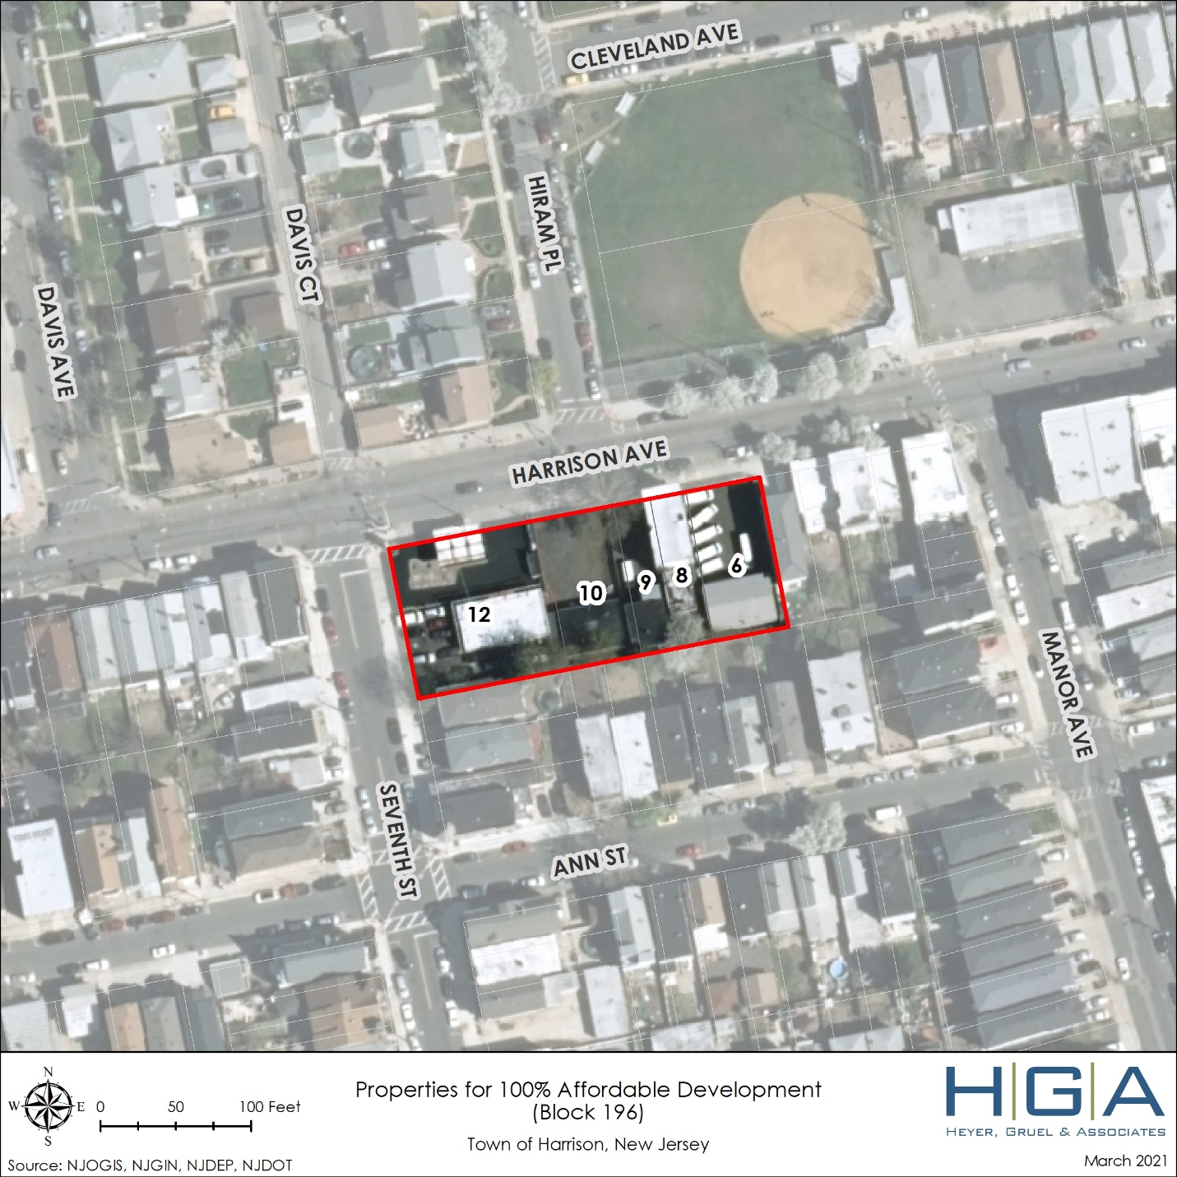

USE OF SURPLUS UNITS
Any surplus credits generated would be applied to any future obligation that the Town may have.

ADDITIONAL REQUIREMENTS
Very Low-Income Requirement: The Town will ensure that 13% of all of the affordable units, with the exception of units constructed as of July 1, 2008 and units subject to preliminary or final site plan approval prior to that date, will be affordable to very low-income households. Half of the very low-income units will be made available to families.
Rental Bonus Credits: All rental bonus credits claimed in this plan have been applied in accordance with N.J.A.C. 5:93-5.15(d).
Low/Moderate Income Split: At least half of the units addressing the Town’s obligation shall be affordable to very-low income and low-income households, and the remaining will be affordable to moderate-income households.
Rental Requirement: At least 25% of the Town’s obligation will be met through rental units, and at least half of these units will be available to families.
Round 3 Family Requirement: At least half of the units addressing the Town’s obligation will be available to families.
Age Restricted Cap: The Town agrees to comply with COAH’s Round 2 age-restricted cap of 25%. The Town is not requesting a waiver to exceed the age-restricted cap.
Spending Plan: On May 26, 2020, the Town adopted a Spending Plan, which was approved by the Court as a component of the Town’s JOR via an Order dated June 4, 2020. The Town prepared an amended Spending Plan, which was approved by the Court via Consent Order, dated April 15, 2021, and adopted by the Town Council on April 2020, 2021.
Affirmative Marketing: The individual developers will be responsible to ensure that proper affirmative marketing of all of the affordable units is properly implemented.
UHAC: All affordable units created through the provisions of this Plan shall be developed in conformance with the Uniform Housing Affordability Controls (UHAC) pursuant to N.J.A.C. 5:80-26.1 et seq. or any successor legislation, with the exception of the very-low-income requirement as described above.

SUMMARY OF FAIR SHARE COMPLIANCE
Present Need | 155
The Town’s Rehabilitation Program supplemented with additional monies from HOME and CDBG Programs | 153
224 N 2nd Street | 2
Prior Round Obligation (1987-1999) | 30
Harrison Senior Housing | 7
Bonus Credit | 2
Waterfront Redevelopment Area  Site #1 | 21
Prior Round Total | 30
Third Round | 429
Harrison Senior Housing | 8
Proposed SH Senior Housing Zone | 98
Waterfront Redevelopment Area  Site #1 | 49
Waterfront Redevelopment Area  Site #2 | 46
Waterfront Redevelopment Area  Site #3 | 120
Total Affordable Units | 321
Rental Bonus Credits  (from Redevelopment Area sites) | 108
Third Round Total | 429
Additional Measures | -
100% Affordable Development – Block 196 Lots 6, 8, 9, 10 & 12 | 25-40

Very-Low Breakdown
SH Zone: | 14 very low-income age-restricted units
Site 1: | 10 very low-income family units
Site 2: | 6 very low-income family units
Site 3: | 16 very low-income family units
Total affordable units constructed/to be constructed After 7/1/2008: |  | 349
 |  | Required | Proposed
13%: |  | 46 | 46
50% Required to be Family: |  | 23 | 32

AFFORDABLE HOUSING ORDINANCES AND RESOLUTIONS
As of the writing of this Plan, the Town of Harrison as adopted the following ordinances and resolutions pertaining to affordable housing:
- Ordinance #1413 amending and supplementing the municipal code to address Fair Housing Act (FHA) and Uniform Housing Affordability Controls (UHAC) requirements, adopted on May 26, 2020
- Ordinance #1414 adopting amendments to the Waterfront Redevelopment Plan Area, adopted on May 26, 2020
- Ordinance #1415 repealing and replacing Chapter 15.36 with Affordable Housing Development Fees, adopted on May 26, 2020
- Ordinance #1404 amending Chapter 17 Land Development Ordinance to include provisions for the Affordable Senior Housing Zone, adopted June 30, 2020
- Resolution #2020-86 appointing Paul J. Zarbetski as Municipal Housing Liaison, adopted on May 26, 2020
- Resolution #2020-88 adopting the Affirmative Marketing Plan, adopted on May 26, 2020
- Resolution #2020-90 authorizing the adoption of the Home Rehabilitation Program Operating Manual, adopted on May 5, 2020
- Resolution #2020-91 endorsing and seeking court approval of the Housing Element and Fair Share Plan, adopted on May 26, 2020
- Resolution #2021-__ adopting the amended Spending Plan, adopted on April 20, 2021

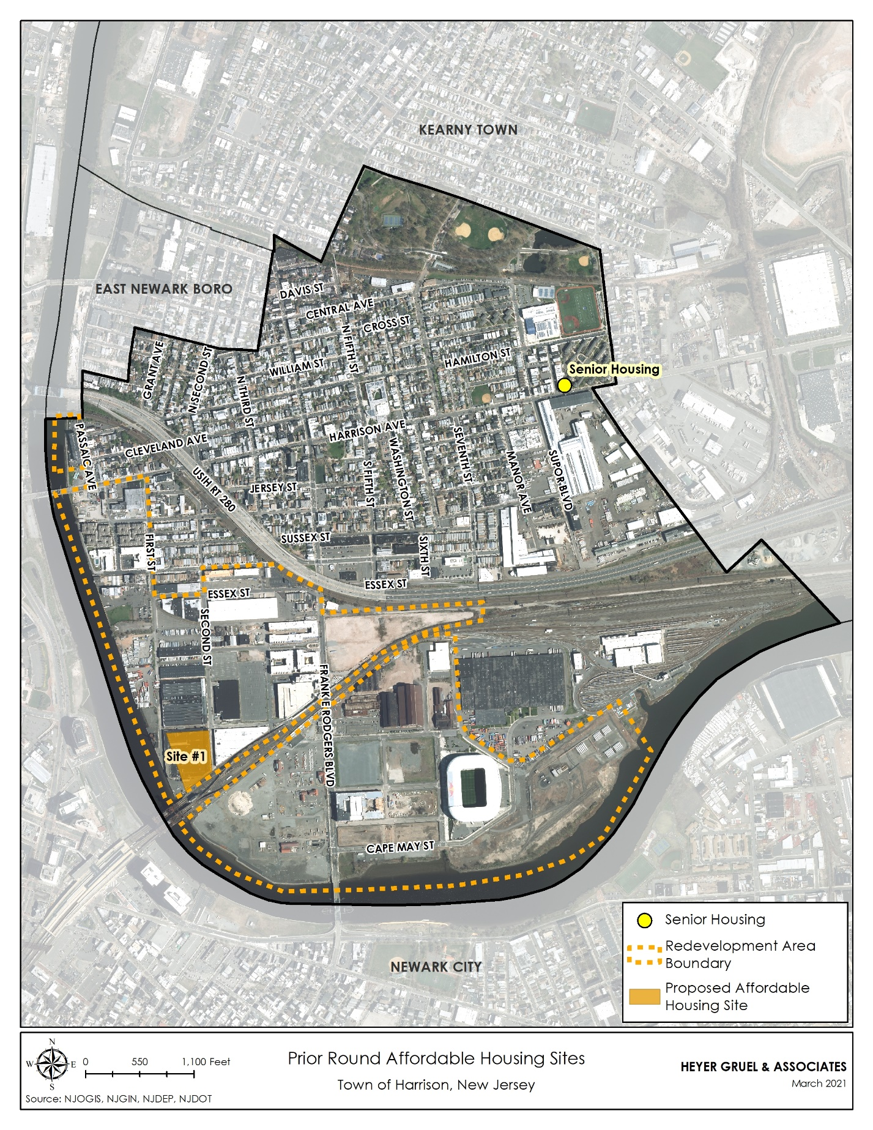

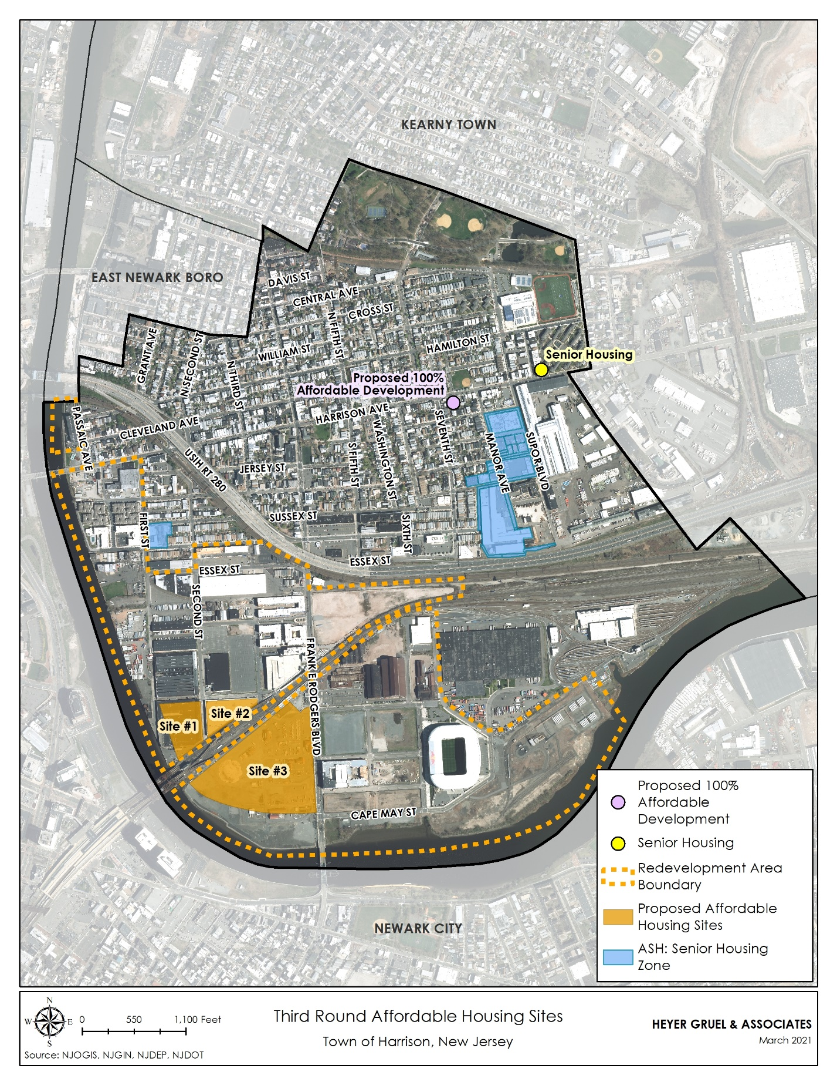

Prepared by the Affordable Housing Professionals of New Jersey

